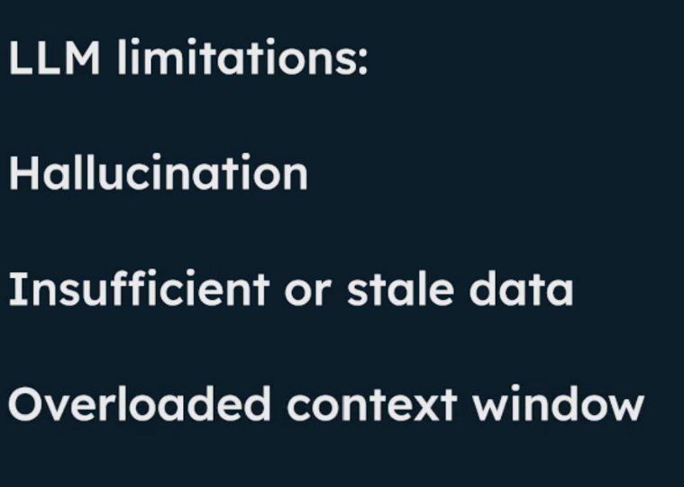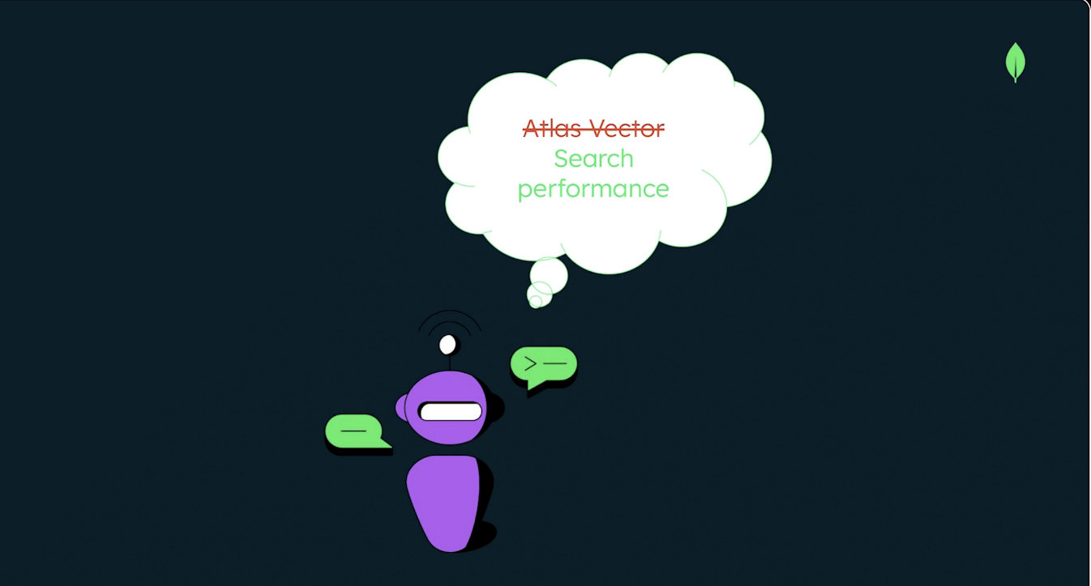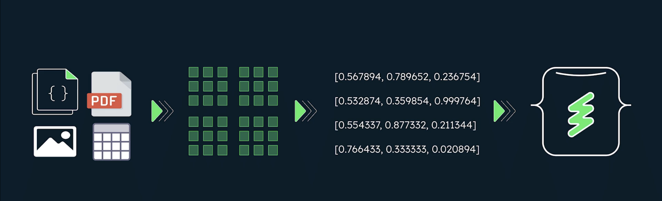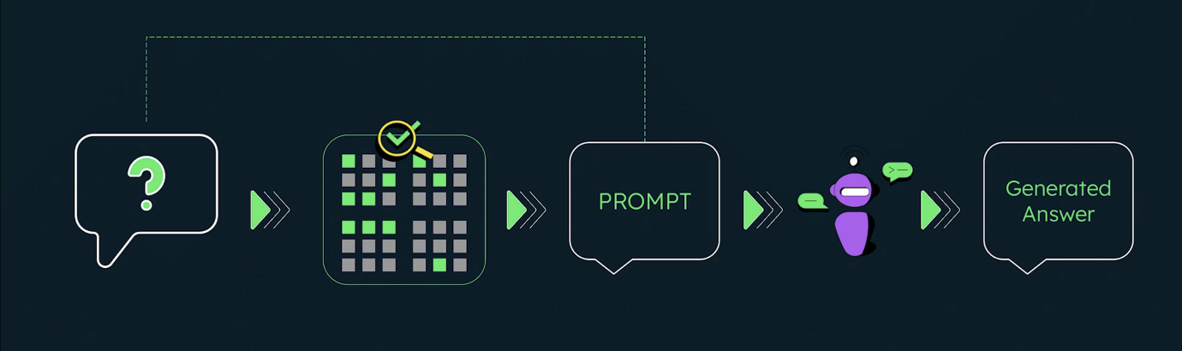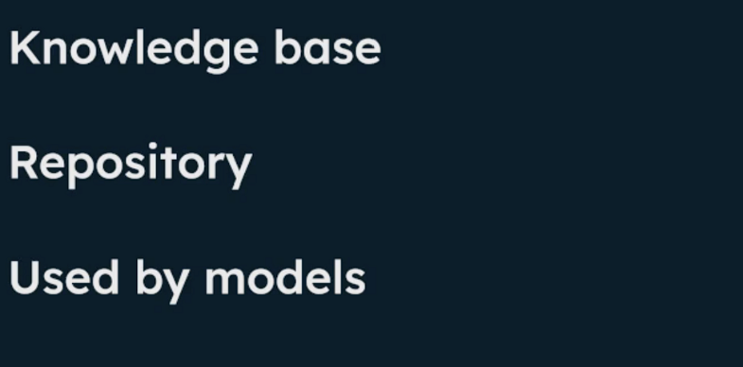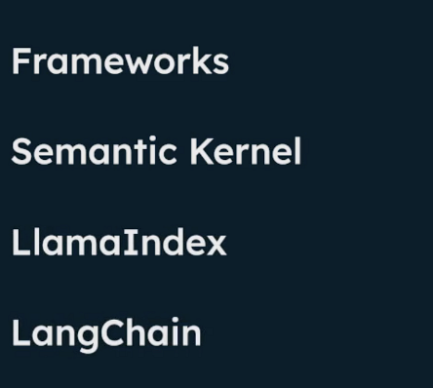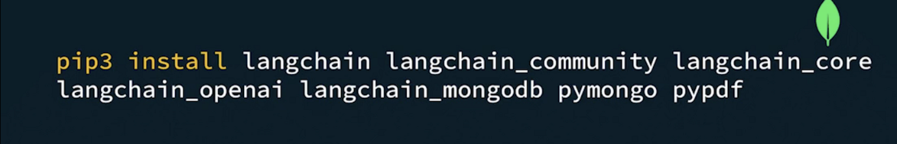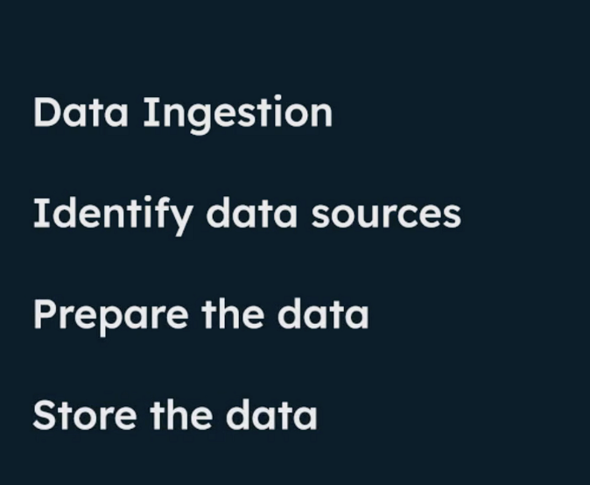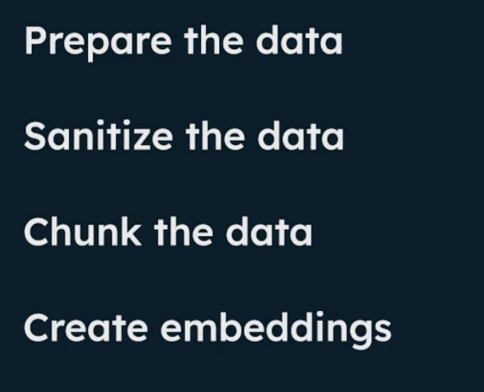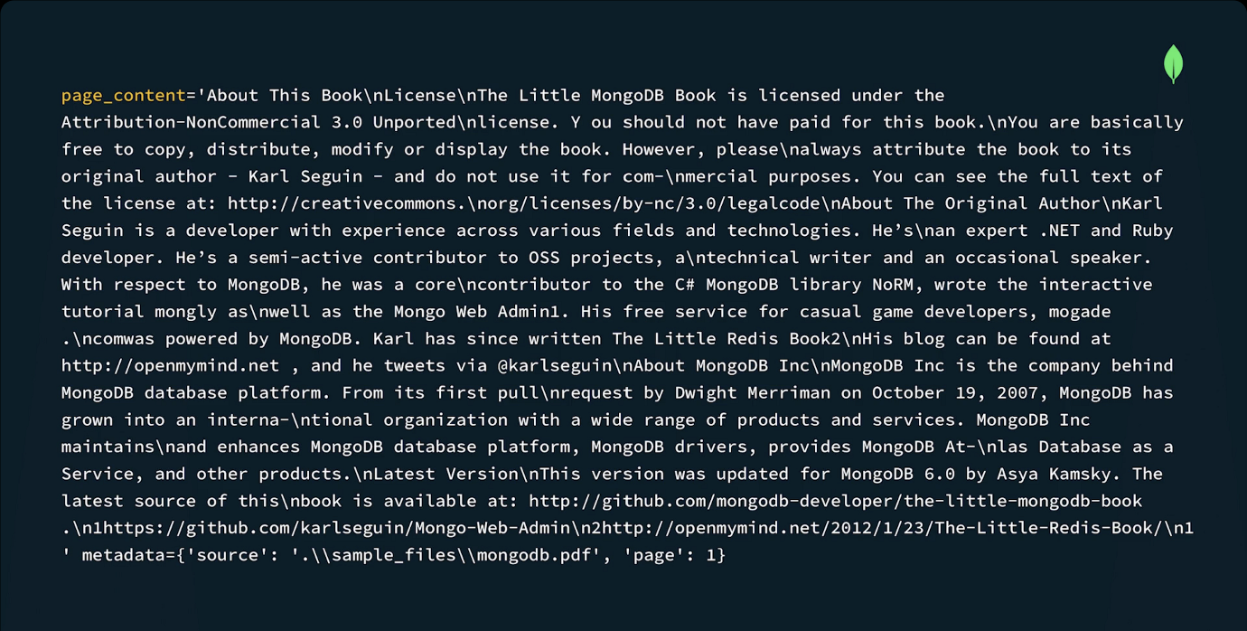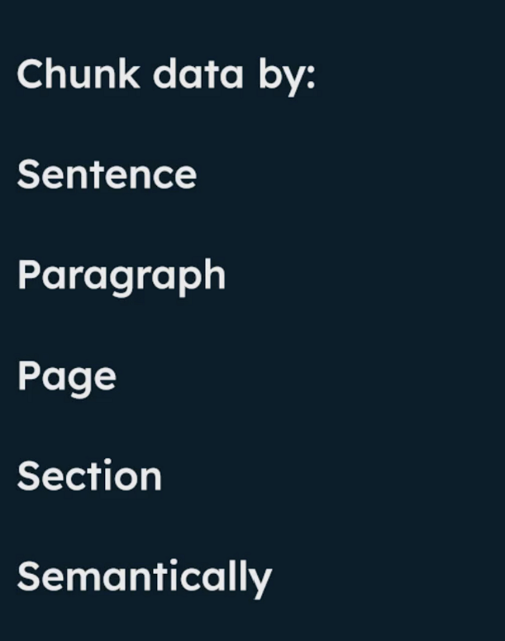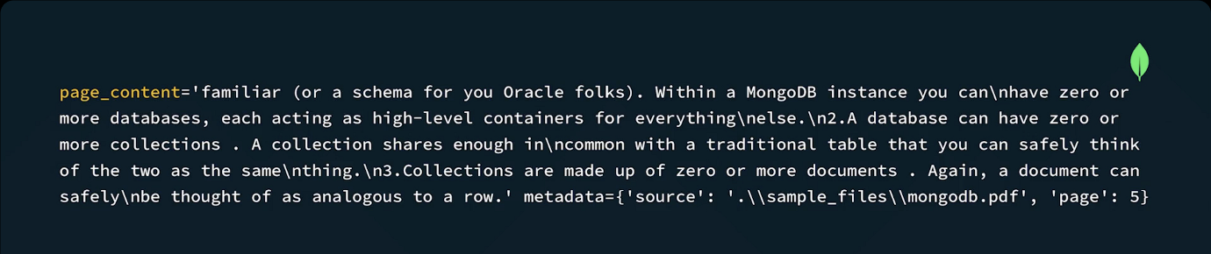

Code Summary: Preparing the Data
Below is an overview of the code that sanitizes the data, chunks it, generates metadata, creates embeddings, and stores it in MongoDB. You can also view and fork the code from the Curriculum GitHub repository.
Prerequisites
- Atlas Cluster Connecting String
- OpenAI API Key
- Voyage AI API Key
Usage
Install the requirements:
pip3 install langchain langchain_community langchain_core langchain_voyageai langchain_openai langchain_mongodb pymongo pypdf

Create a key_param file with the following content:
MONGODB_URI=<your_atlas_connection_string>
VOYAGE_API_KEY=<your_voyageai_api_key>
LLM_API_KEY=<your_llm_api_key>

Note: Replace the MONGODB_URI, VOYAGE_API_KEY and LLM_API_KEY values with your own values.
Load the sample data into your Atlas Cluster:
python load_data.py

load_data.py file
This code ingests a pdf, removes empty pages, chunks the pages into paragraphs, generates metadata for the chunks, creates embeddings, and stores the chunks and their embeddings in a MongoDB collection.
The embedding model used in the examples below is the voyage-3.5-lite. The voyage-3.5-litemodel from Voyage AI is a state-of-the-art embedding model designed for efficient and high-quality text retrieval. It supports multiple embedding dimensions—2048, 1024, 512, and 256—and offers various quantization options, including int8 and binary. Voyage-3.5-lite is suitable for a wide range of domains, such as technical documentation, code, law, finance, web reviews, long documents, and conversations.
To get started with Voyage AI, check out the Voyage AI documentation.
from pymongo import MongoClient
from langchain_openai import ChatOpenAI
from langchain_voyageai import VoyageAIEmbeddings
from langchain_community.vectorstores import MongoDBAtlasVectorSearch
from langchain_community.document_loaders import PyPDFLoader
from langchain.text_splitter import RecursiveCharacterTextSplitter
from langchain_community.document_transformers.openai_functions import (
create_metadata_tagger,
)

import key_param

# Set the MongoDB URI, DB, Collection Names

client = MongoClient(key_param.MONGODB_URI)
dbName = "book_mongodb_chunks"
collectionName = "chunked_data"
collection = client[dbName][collectionName]

loader = PyPDFLoader(".\sample_files\mongodb.pdf")
pages = loader.load()
cleaned_pages = []

for page in pages:
if len(page.page_content.split(" ")) > 20:
cleaned_pages.append(page)

text_splitter = RecursiveCharacterTextSplitter(chunk_size=500, chunk_overlap=150)

schema = {
"properties": {
"title": {"type": "string"},
"keywords": {"type": "array", "items": {"type": "string"}},
"hasCode": {"type": "boolean"},
},
"required": ["title", "keywords", "hasCode"],
}

llm = ChatOpenAI(
openai_api_key=key_param.LLM_API_KEY, temperature=0, model="gpt-3.5-turbo"
)

document_transformer = create_metadata_tagger(metadata_schema=schema, llm=llm)

docs = document_transformer.transform_documents(cleaned_pages)

split_docs = text_splitter.split_documents(docs)

embeddings = VoyageAIEmbeddings(voyage_api_key=key_param.VOYAGE_API_KEY, model="voyage-3.5-lite")

vectorStore = MongoDBAtlasVectorSearch.from_documents(
split_docs, embeddings, collection=collection
)

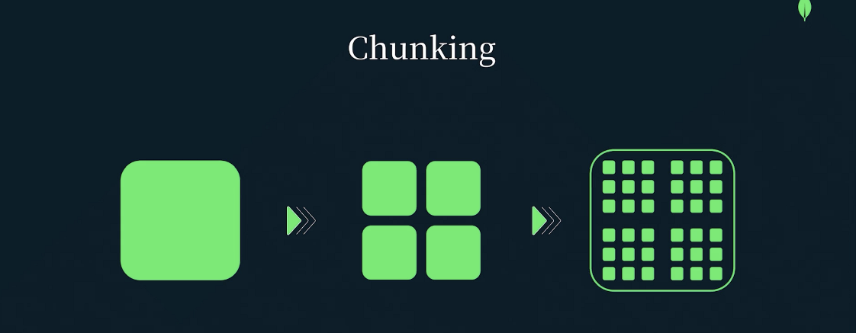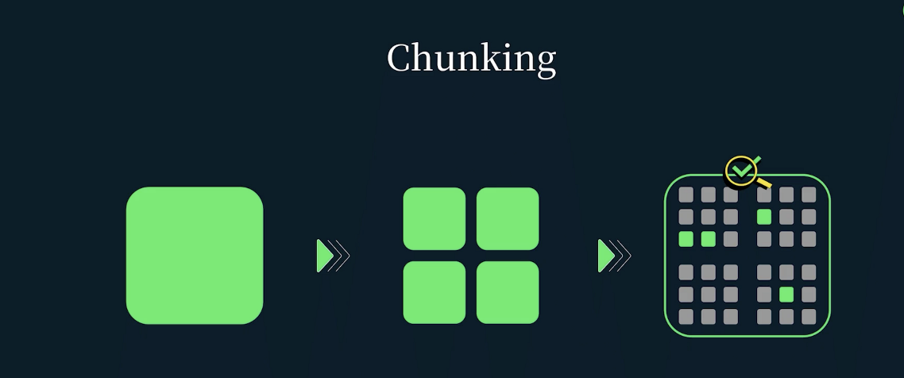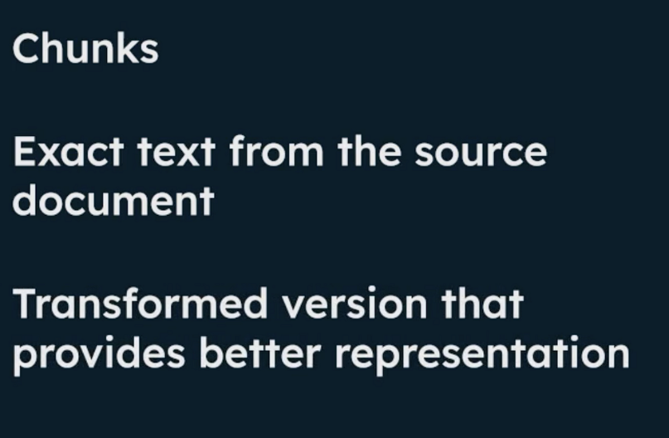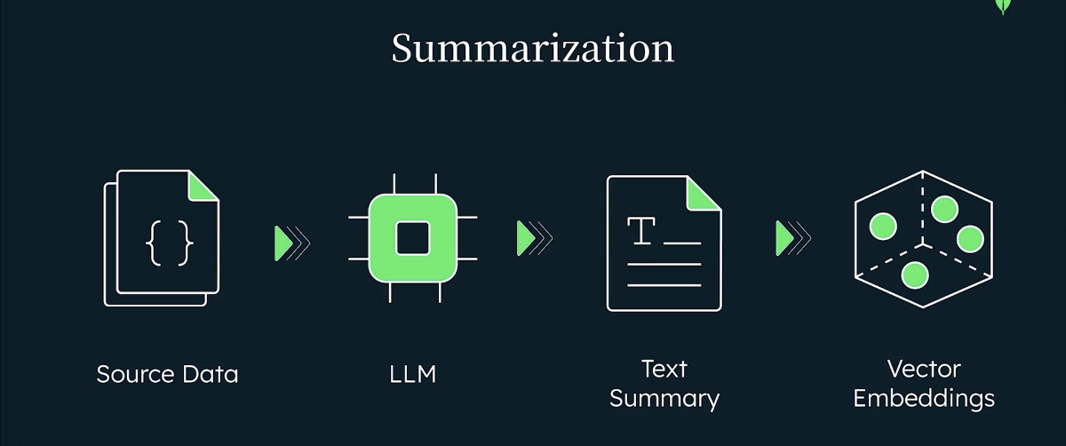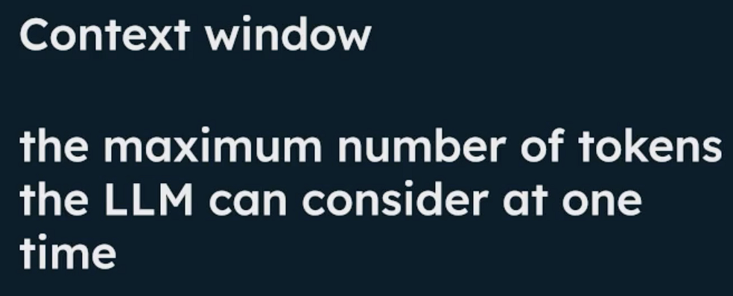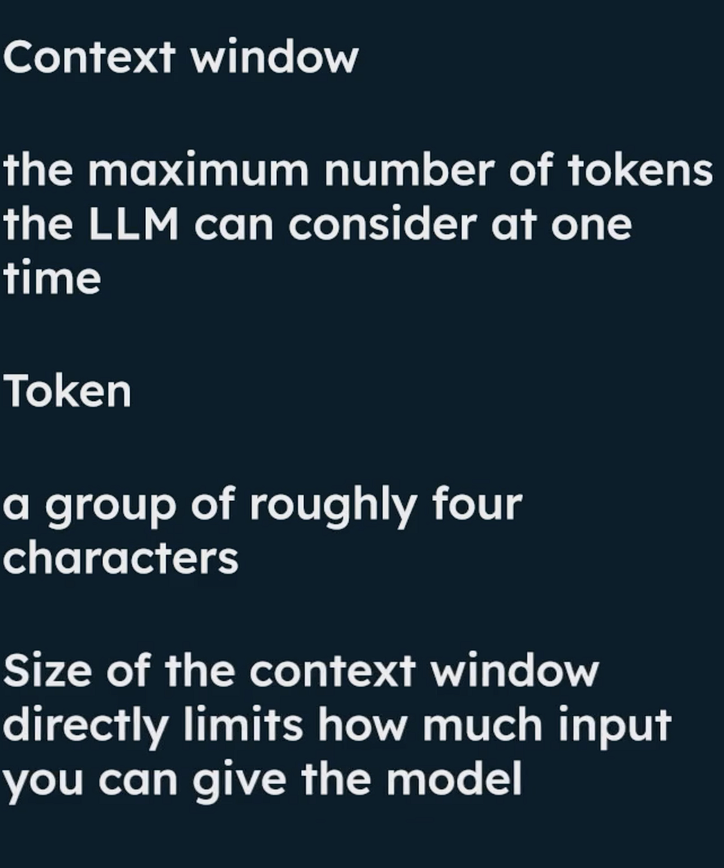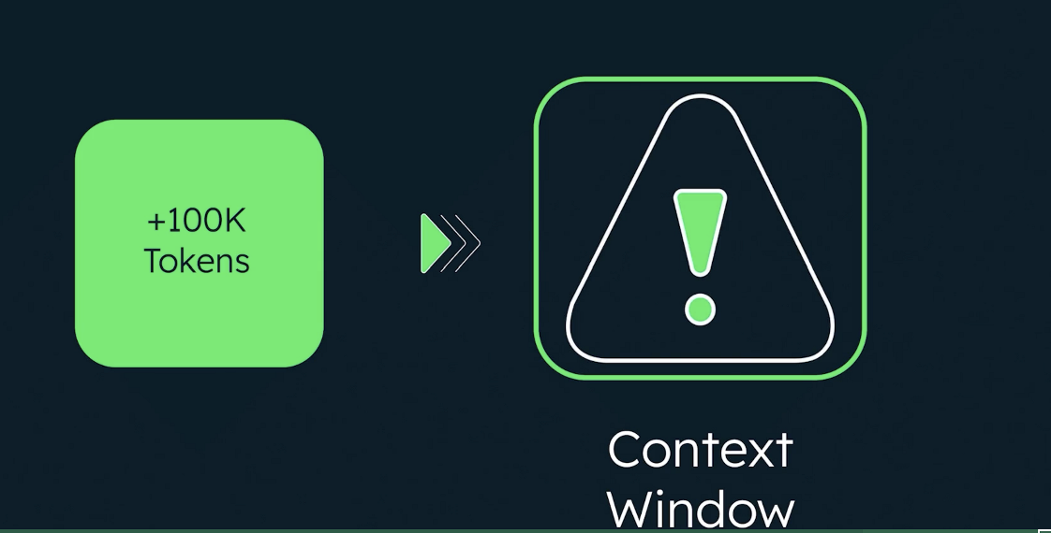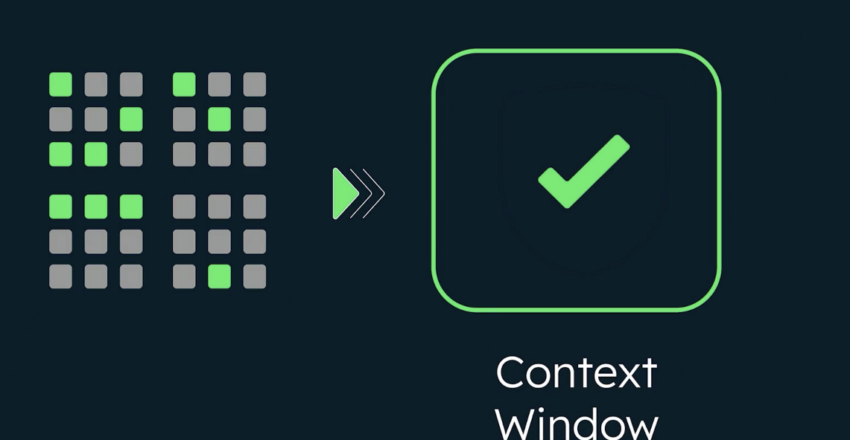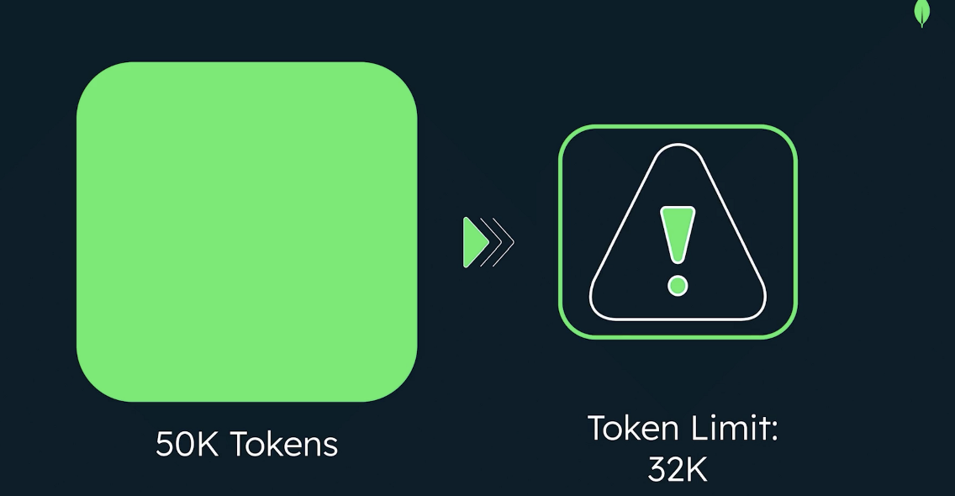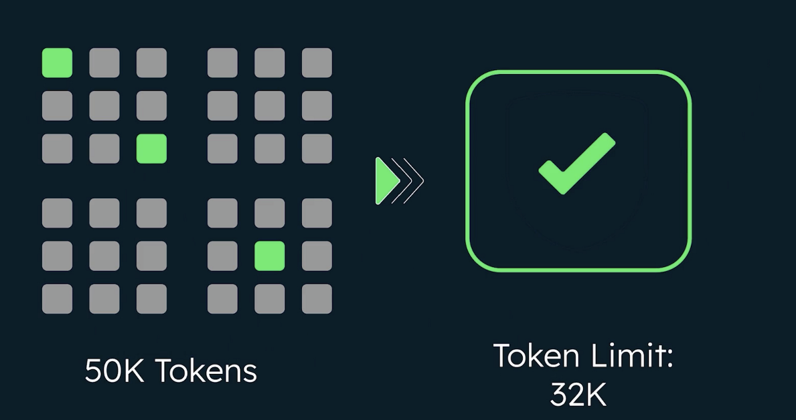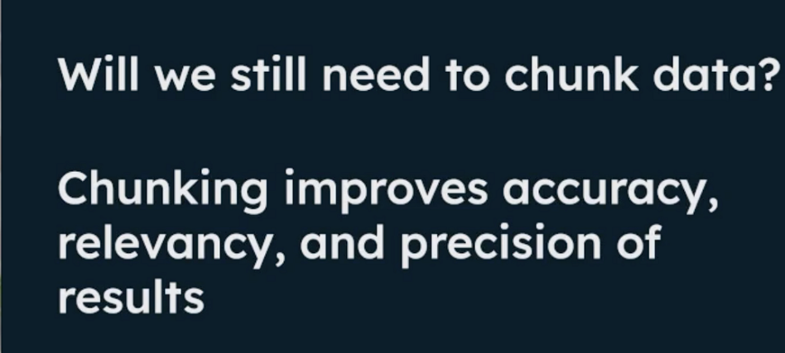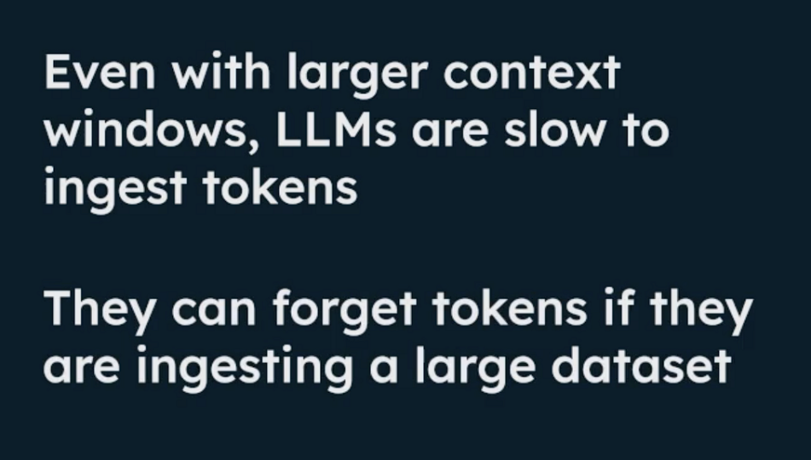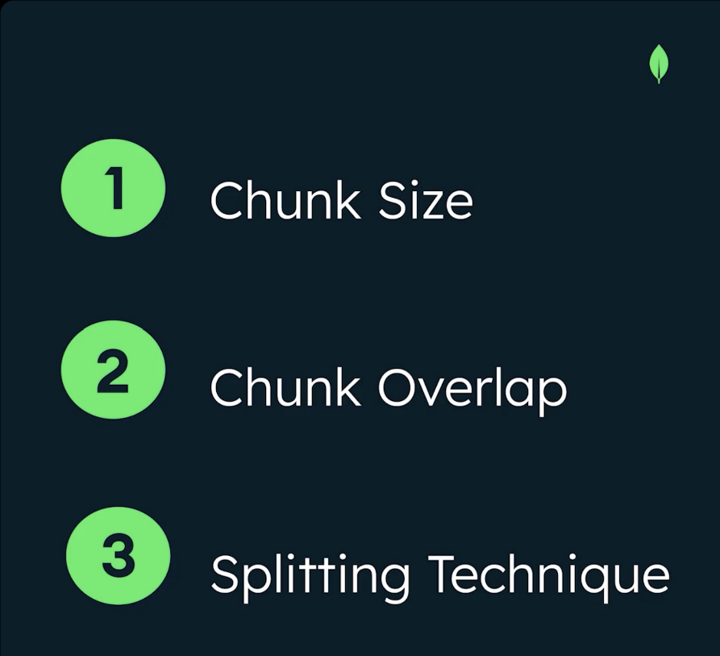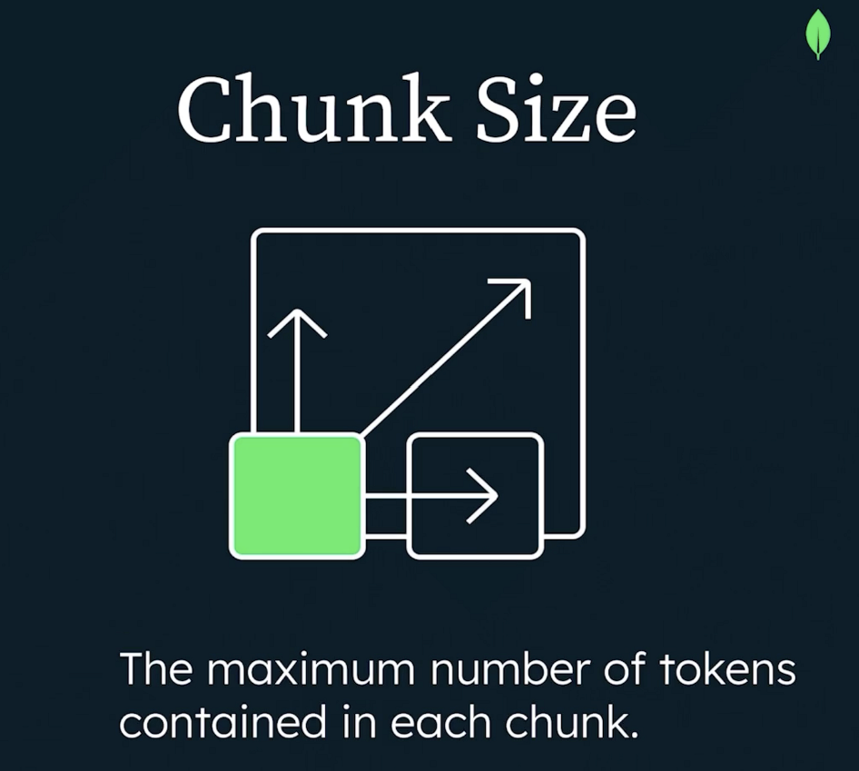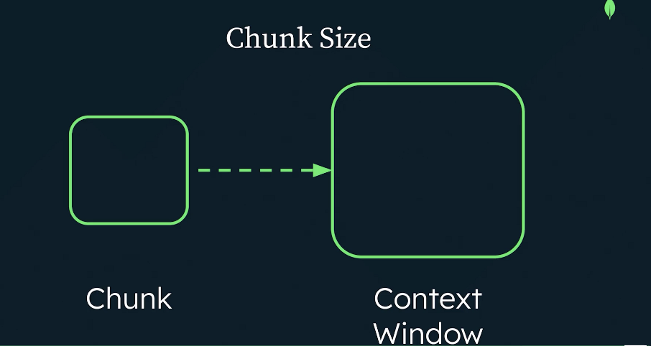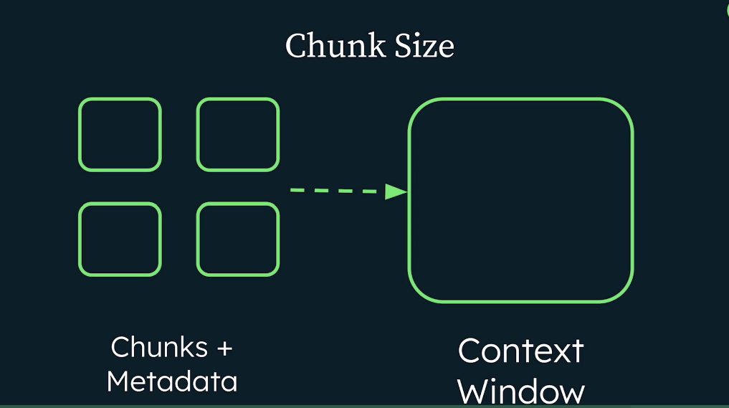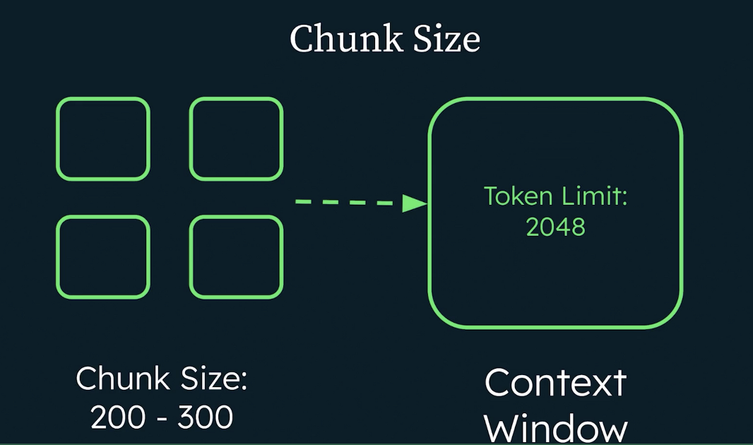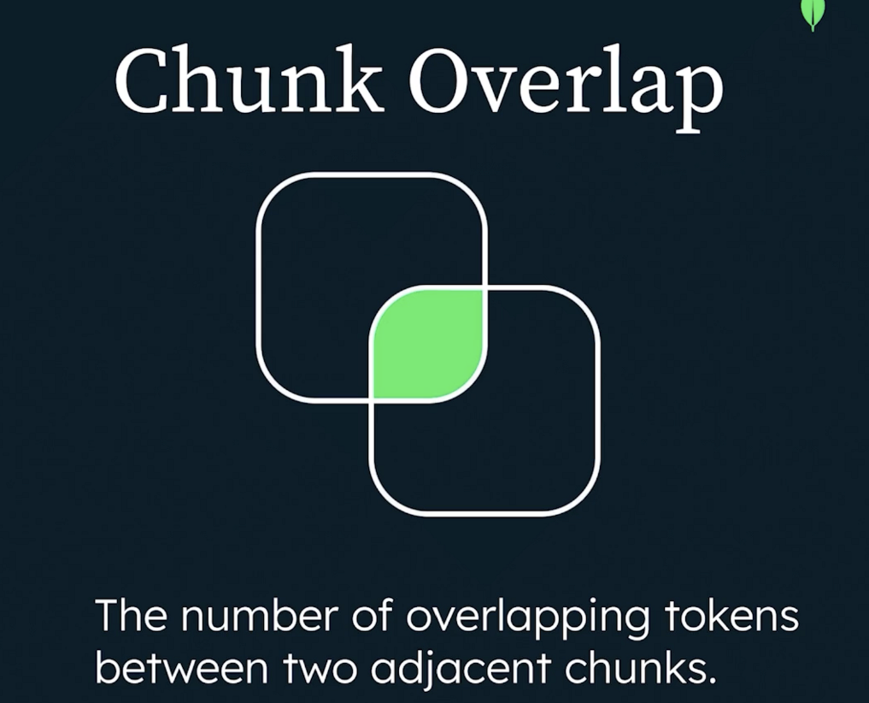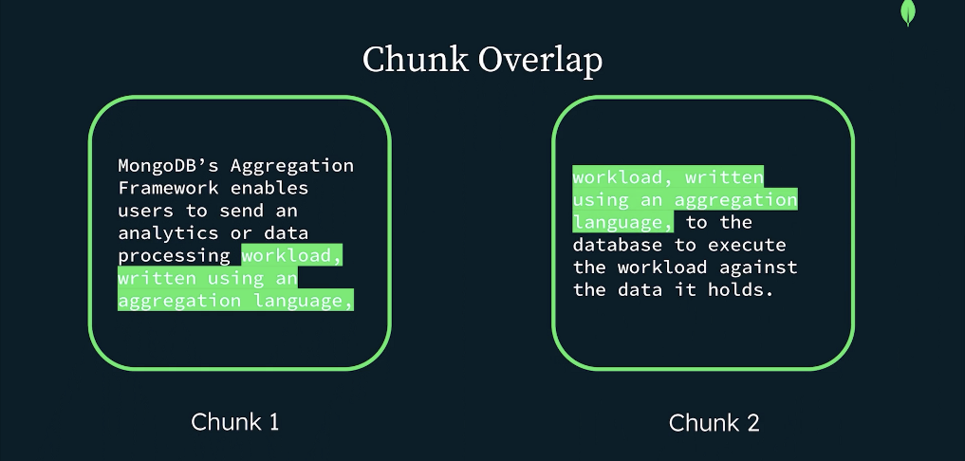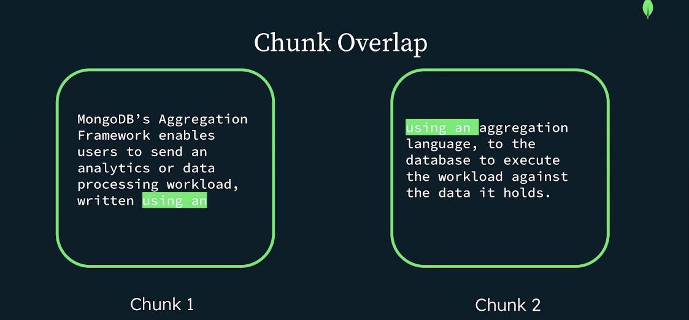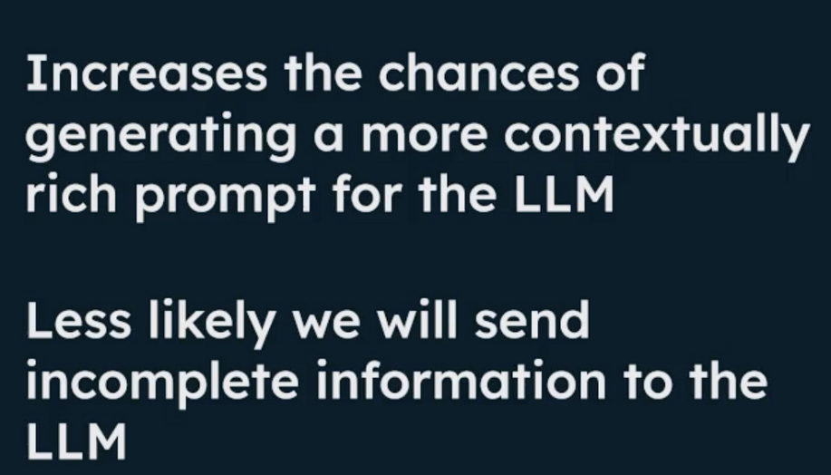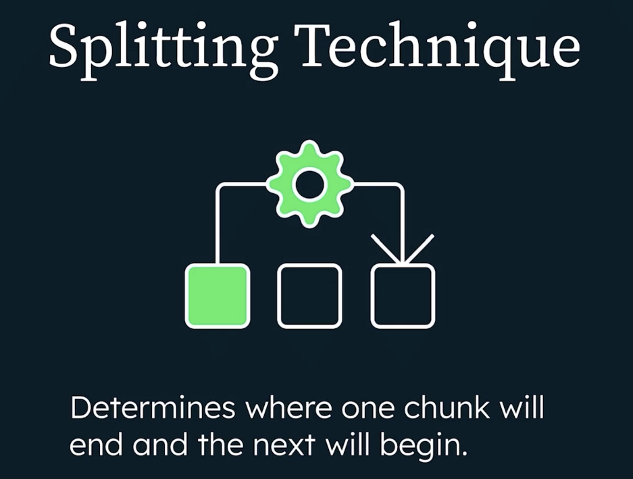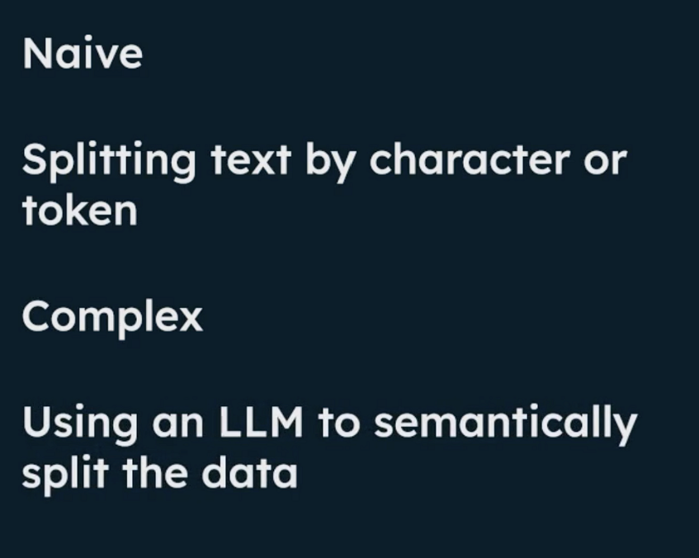
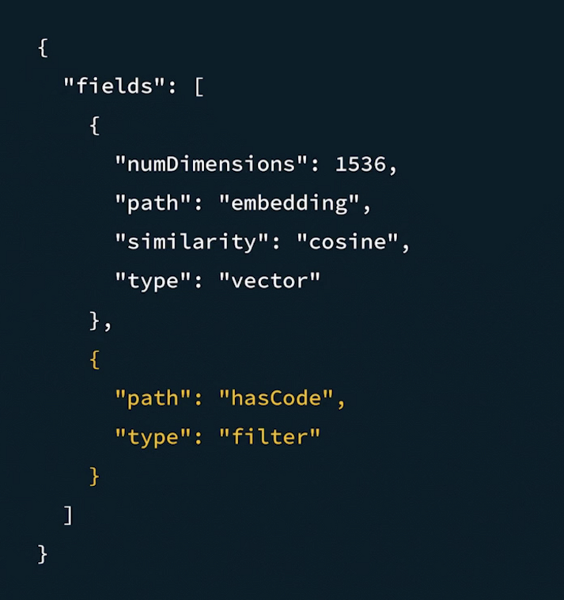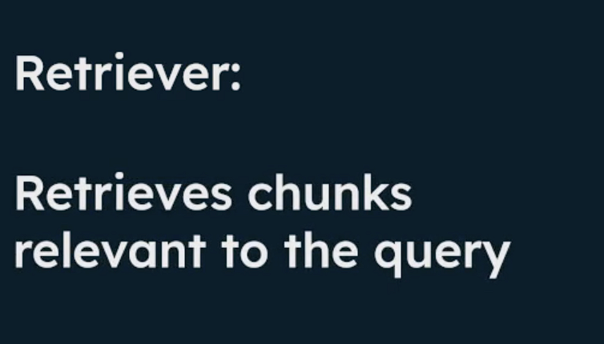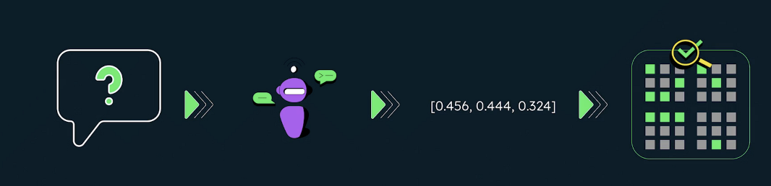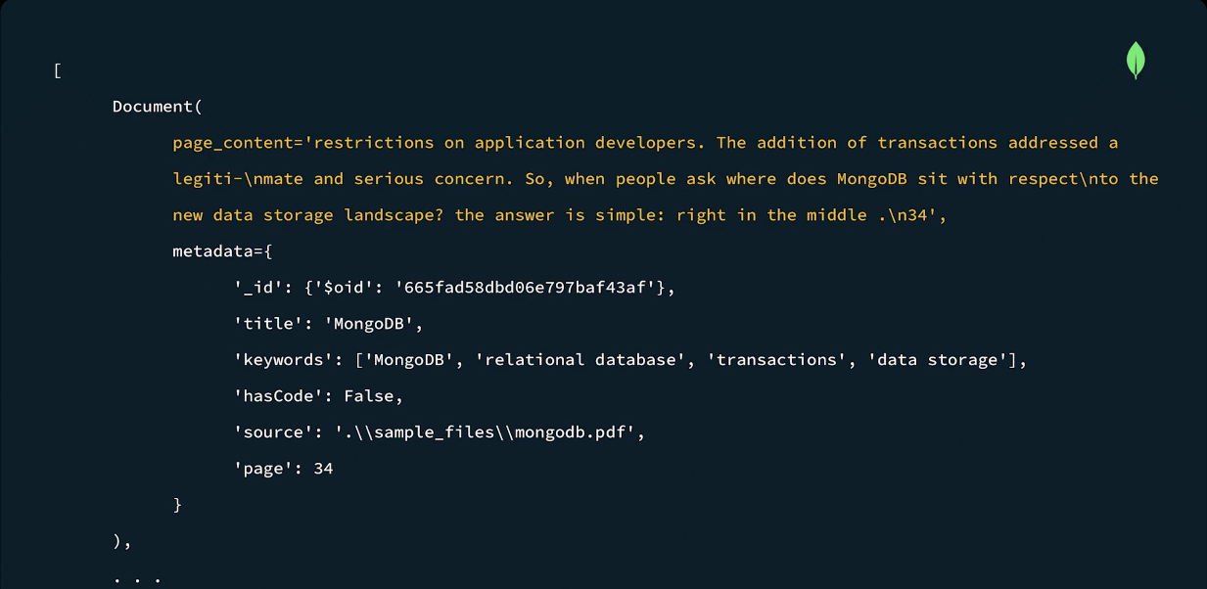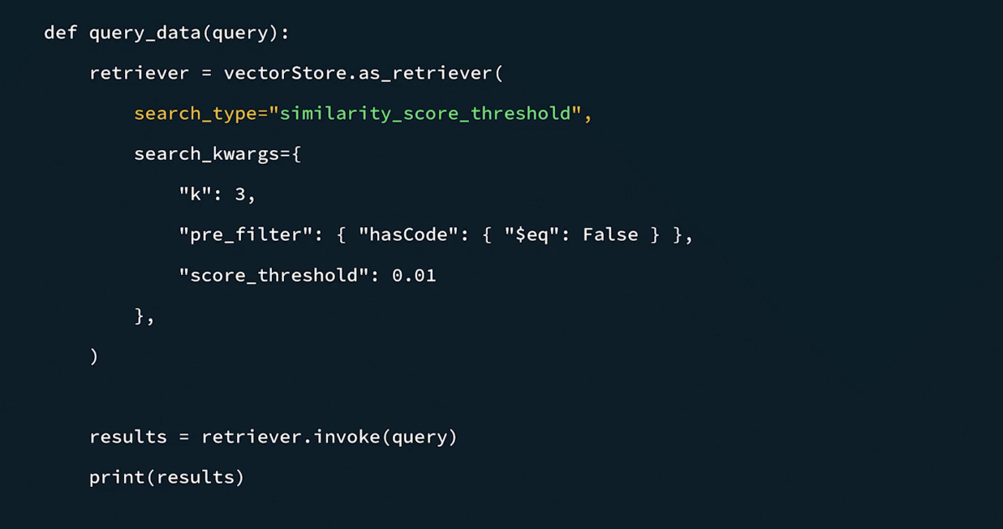

Code Summary: Retrieving the Data
This code implements the retriever component of our RAG system, using Atlas Vector Search. You can also view or fork the code from the Curriculum GitHub repository.
Prerequisites
- Atlas Cluster Connection String
- OpenAI API Key
- Voyage AI API Key
- Data loaded into Atlas
Create the following vector search index, named vector_index, on the chunked_data collection in your Atlas Cluster:
{
"fields": [
{
"numDimensions": 1536,
"path": "embedding",
"similarity": "cosine",
"type": "vector"
},
{
"path": "hasCode",
"type": "filter"
}
]
}

Note:The default number of dimensions for the voyage-3.5-lite embedding model is 1024. We have the option to use 256, 512, or 2048 dimensions with the voyage 3.5 models.
Usage
rag.py file
The following code sets Atlas Vector Search as the vectorStore. It takes the query embeddings as input and uses that to perform a vector search to retrieve relevant data.
from langchain_mongodb import MongoDBAtlasVectorSearch
from langchain_voyageai import VoyageAIEmbeddings
import key_param

dbName = "book_mongodb_chunks"
collectionName = "chunked_data"
index = "vector_index"

vectorStore = MongoDBAtlasVectorSearch.from_connection_string(
key_param.MONGODB_URI,
dbName + "." + collectionName,
VoyageAIEmbeddings(voyage_api_key=key_param.VOYAGE_API_KEY, model="voyage-3.5-lite"),
index_name=index,
)

def query_data(query):
retriever = vectorStore.as_retriever(
search_type="similarity",
search_kwargs={
"k": 3
},
)

results = retriever.invoke(query)
print(results)

Update the query_data function in the rag.py file by passing in a question:
query_data("What is the difference between a database and collection in MongoDB?")

Run the demo:
python rag.py

Add a prefilter to the retriever
Update the query_data function in the rag.py file to include a pre_filter object.
def query_data(query):
retriever = vectorStore.as_retriever(
search_type="similarity_score_threshold",
search_kwargs={
"k": 3,
"pre_filter": { "hasCode": { "$eq": False } },
"score_threshold": 0.01
},
)
results = retriever.invoke(query)
print(results)

rag.py file with filtering
This code generates vector embeddings for a query and uses them to perform a vector search on the chunked_data collection. It also prefilters the data to find chunks without code.
from langchain_mongodb import MongoDBAtlasVectorSearch
from langchain_voyageai import VoyageAIEmbeddings
import key_param

dbName = "book_mongodb_chunks"
collectionName = "chunked_data"
index = "vector_index"

vectorStore = MongoDBAtlasVectorSearch.from_connection_string(
key_param.MONGODB_URI,
dbName + "." + collectionName,
VoyageAIEmbeddings(voyage_api_key=key_param.VOYAGE_API_KEY, model="voyage-3.5-lite"),
index_name=index,
)

def query_data(query):
retriever = vectorStore.as_retriever(
search_type="similarity",
search_kwargs={
"k": 3,
"pre_filter": { "hasCode": { "$eq": False } },
"score_threshold": 0.01
},
)

results = retriever.invoke(query)
print(results)

query_data("When did MongoDB begin supporting multi-document transactions?")

Run the demo:
python rag.py

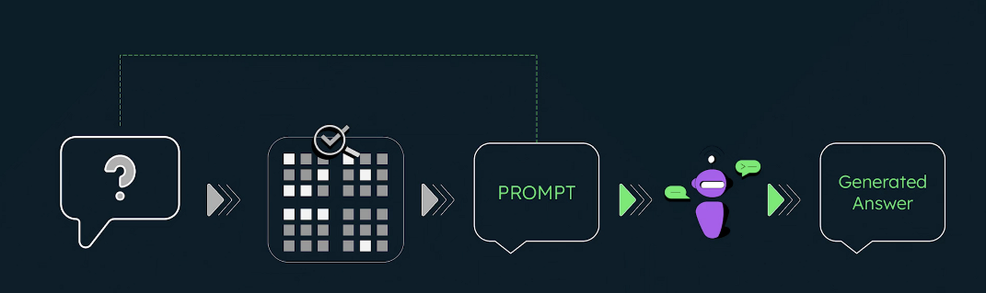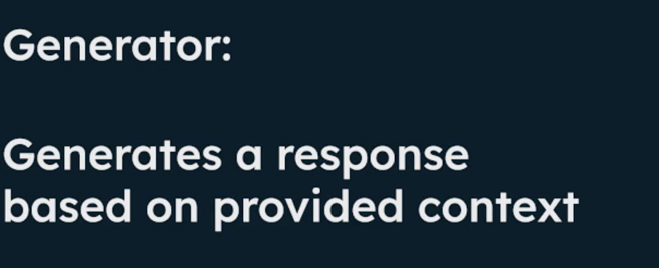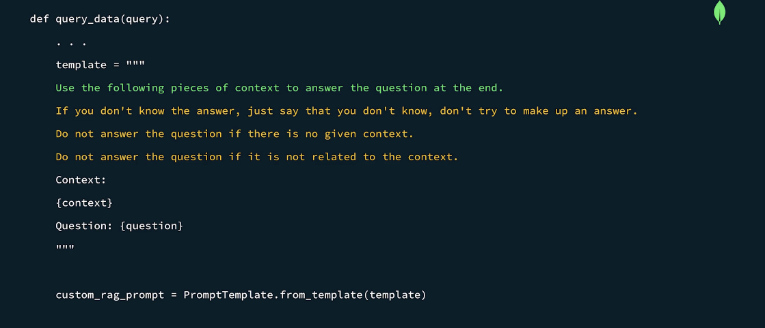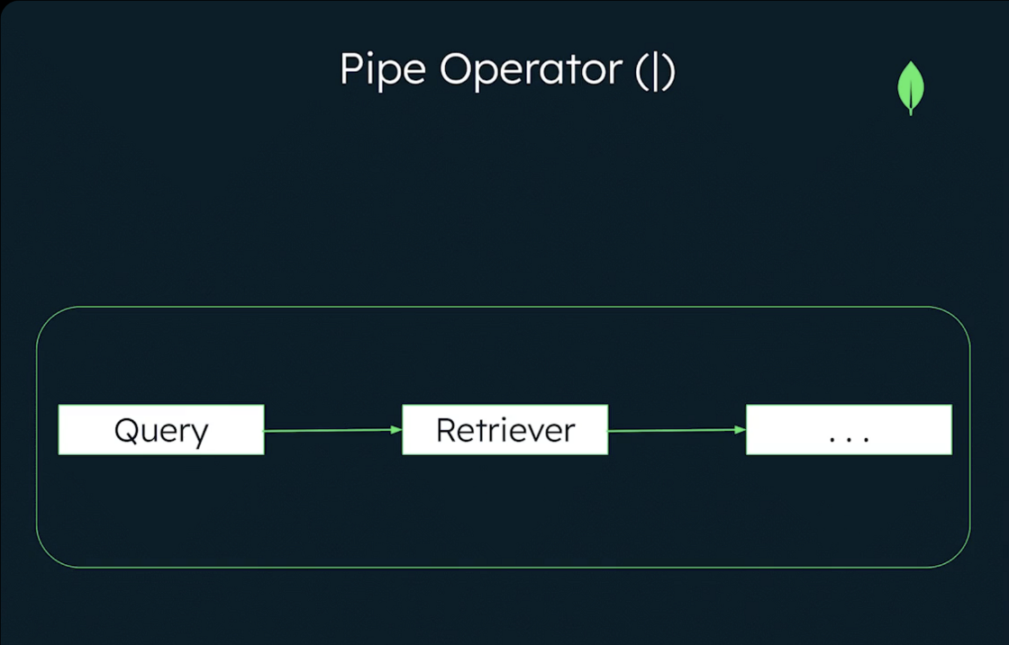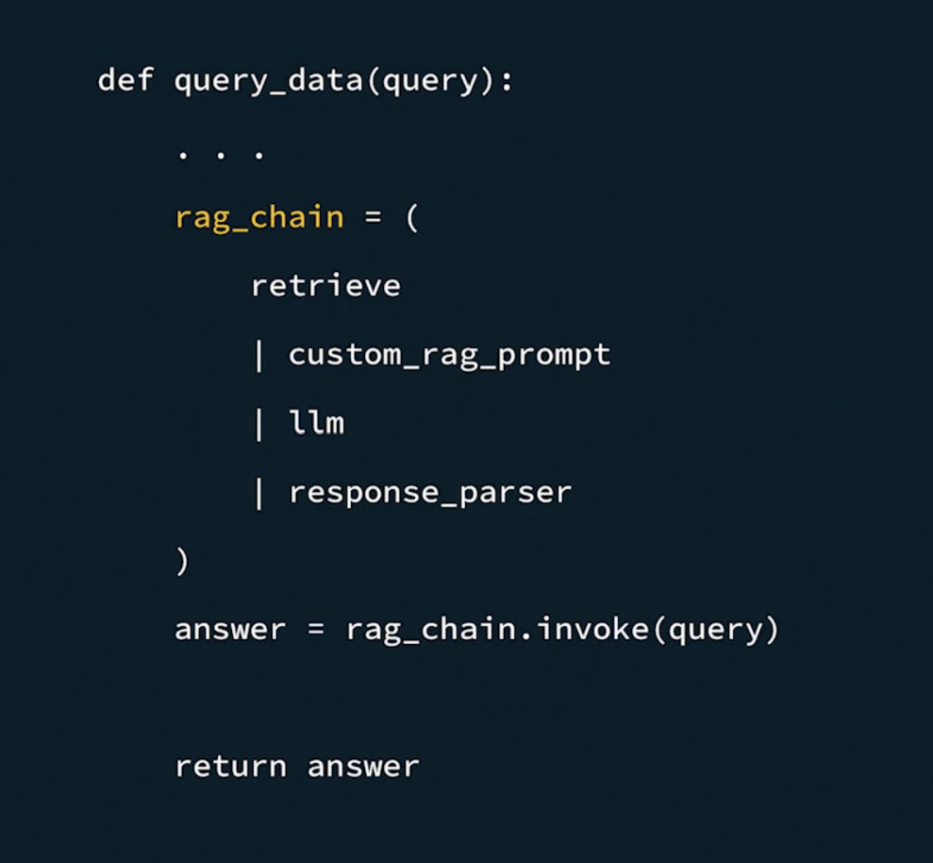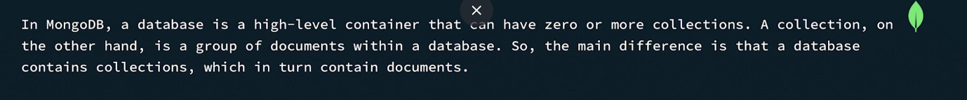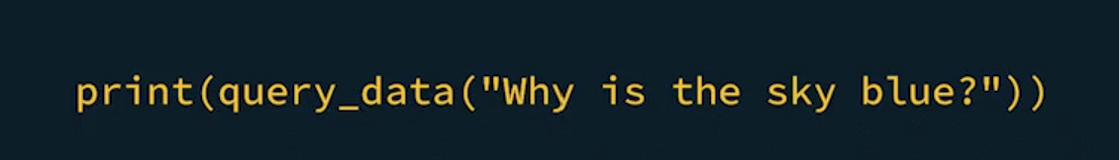

Code Summary: Answer Generation
In the final step of building our RAG system, we'll create the answer generation component and put together the entire RAG system. Follow the steps below or you can fork the code from the Curriculum GitHub repository. As a more advanced step, you can use your own source of data and construct your own questions which suit that data.
Prerequisites
- Atlas Cluster Connection String
- OpenAI API Key
- Voyage AI API Key
- Data loaded into Atlas
Usage
rag.py
If you’ve been following along for this demo thus far, your rag.py should look something like this at this point:
from langchain_mongodb import MongoDBAtlasVectorSearch
from langchain_voyageai import VoyageAIEmbeddings
import key_param

dbName = "book_mongodb_chunks"
collectionName = "chunked_data"
index = "vector_index"

vectorStore = MongoDBAtlasVectorSearch.from_connection_string(
key_param.MONGODB_URI,
dbName + "." + collectionName,
VoyageAIEmbeddings(voyage_api_key=key_param.VOYAGE_API_KEY, model="voyage-3.5-lite"),
index_name=index,
)

def query_data(query):
retriever = vectorStore.as_retriever(
search_type="similarity",
search_kwargs={
"k": 3,
"pre_filter": { "hasCode": { "$eq": False } },
"score_threshold": 0.01
},
)

results = retriever.invoke(query)
print(results)

query_data("When did MongoDB begin supporting multi-document transactions?")

Import additional modules:
from langchain.prompts import PromptTemplate
from langchain_core.runnables import RunnablePassthrough
from langchain_core.output_parsers import StrOutputParser

Create a Prompt Template
Here is an example of a template you might create to help the RAG system answer questions:
template = """
Use the following pieces of context to answer the question at the end.
If you don't know the answer, just say that you don't know, don't try to make up an answer.
Do not answer the question if there is no given context.
Do not answer the question if it is not related to the context.
Do not give recommendations to anything other than MongoDB.
Context:
{context}
Question: {question}
"""

Linking the Chain
We'll replace the print(results) section with our RAG chain sequence to put our whole RAG system together:
custom_rag_prompt = PromptTemplate.from_template(template)

retrieve = {
"context": retriever | (lambda docs: "\n\n".join([d.page_content for d in docs])),
"question": RunnablePassthrough()
}

llm = ChatOpenAI(openai_api_key=key_param.LLM_API_KEY, temperature=0)

response_parser = StrOutputParser()

rag_chain = (
retrieve
| custom_rag_prompt
| llm
| response_parser
)

answer = rag_chain.invoke(query)

return answer

Write a query
Update the query_data function in the rag.py file by passing in a question:
query_data("What is the difference between a database and collection in MongoDB?")

rag.py
After this, your rag.py file should look like this:
from langchain_mongodb import MongoDBAtlasVectorSearch
from langchain_openai import ChatOpenAI
from langchain_voyageai import VoyageAIEmbeddings
from langchain.prompts import PromptTemplate
from langchain_core.runnables import RunnablePassthrough
from langchain_core.output_parsers import StrOutputParser
import key_param

dbName = "book_mongodb_chunks"
collectionName = "chunked_data"
index = "vector_index"

vectorStore = MongoDBAtlasVectorSearch.from_connection_string(
key_param.MONGODB_URI,
dbName + "." + collectionName,
VoyageAIEmbeddings(voyage_api_key=key_param.VOYAGE_API_KEY, model="voyage-3.5-lite"),
index_name=index,
)

def query_data(query):
retriever = vectorStore.as_retriever(
search_type="similarity",
search_kwargs={
"k": 3,
"pre_filter": { "hasCode": { "$eq": False } },
"score_threshold": 0.01
},
)

template = """
Use the following pieces of context to answer the question at the end.
If you don't know the answer, just say that you don't know, don't try to make up an answer.
Do not answer the question if there is no given context.
Do not answer the question if it is not related to the context.
Do not give recommendations to anything other than MongoDB.
Context:
{context}
Question: {question}
"""

custom_rag_prompt = PromptTemplate.from_template(template)

retrieve = {
"context": retriever | (lambda docs: "\n\n".join([d.page_content for d in docs])),
"question": RunnablePassthrough()
}

llm = ChatOpenAI(openai_api_key=key_param.LLM_API_KEY, temperature=0)

response_parser = StrOutputParser()

rag_chain = (
retrieve
| custom_rag_prompt
| llm
| response_parser
)

answer = rag_chain.invoke(query)

return answer

print(query_data("When did MongoDB begin supporting multi-document transactions?"))

Run the demo
Finally, it’s time to run your RAG application and have it answer your question:
python rag.py

